Spotting Manipulative Techniques in Argument

Cialdini Patterns (https://www.youtube.com/watch?v=cFdCzN7RYbw)
(https://www.f5fp.com/wp-content/uploads/2015/01/Influence-The-Psychology-of-Persuasion-Robert-Cialdini.pdf)

- Authority
- Liking
- Commitment & Consistency
- Scarcity
- Reciprocation
- Social Proof
- Unity (Belonging)

Manipulation Patterns
- Specialness
- Isolation
- Secrecy
- Threats

14 Fox “News” Patterns (Boaz) (ASW: Fox is not “news” it is “entertainment.”)
(https://truthout.org/articles/fourteen-propaganda-techniques-fox-news-uses-to-brainwash-americans/)

- Panic Mongering (Fear)
- Ad Hominem
- Projection/Flipping (I know you are, but what am I?)
- Rewriting History
- Scapegoating
- Conflating violence with power and opposition to violence as weakness
- Bullying: exploiting opponent’s sensitivity or lack of confidence to “win” (zero-sum) by berating
- Confusion
- Populism: identifying with “the people,” and opponent as “elitist” (not of “the people.”
- Invoking the Christian God
- Saturation
- Disparaging Education: “Educational Elites” “Hive mentality”
- Guilt by Association
- Diversion (to avoid accountability)

Condescension, Distraction, Diversion, and Complex Equivalence From Fox News:
If you question and want to hold accountable, the actions of the Unimpeachable Authoritarian and their group, it means that you don’t have enough to do. Get a hobby!
A Few Informal Logical Fallacies

- Red-herring
- Affirming the consequent: If A > B: B Therefore A
- Denying the antecedent: If A > B: ~A Therefore ~B
- Begging the question: Circular Reasoning
- Hasty Generalization
- Existential Fallacy: Universal Premise > particular conclusion
- Black & White
- Equivocation (using term with 2 definitions)
- False Choice/ False Dilemma
- False Attribution (using questionable source)
- Gambler’s Fallacy (assuming probability of next occurance)

- Snuck or implicit premises

- Gaslighting

- Catfishing (pretending to be something other than you are, online, to a vulnerable individual or audience).

Bateson/Dilts Logical Levels:

Boundary violations for (structure of shame, guilt), and
“Belonging” (Supercedes Identity)

- Spiritual (purpose)
- Country
- Community
- Profession
- Family
- Identity
- Beliefs
- Values
- Capabilities
- Behavior
- Environment

“The 10 D’s” (Opposition Tactics) (University of Kansas Community Tool Box)
(https://ctb.ku.edu/en/table-of-contents/advocacy/respond-to-counterattacks/overview-of-opposition-tactics/main)
(documentary “Merchants of Doubt”)
Movie Trailer (1 Min, 59 Sec) https://www.youtube.com/watch?v=j8ii9zGFDtc
(http://www.documentarymania.com/player.php?title=Merchants%20of%20Doubt)
- Deflection
- Delays
- Denials
- Discounting
- Deception
- Dividing
- Dulcifying
- Discrediting
- Destroy
- Deal

Cognitive Dissonance 7 Tells (https://www.youtube.com/watch?v=EVF0ojfhSrE)

- Being Stunned by new information without adjusting perspective
- Inaccurately summarizing the other side’s perspective
- Misreading Nefarious Intent of the Opposing side
- Regularly moving Goalposts
- Yelling or Getting Angry
- Attacking a Person’s Character instead of their Argument
- Retreating from a point without any concession

NLP Presuppositions
- The Map is not the Territory.
- People work perfectly.
- People make the best choice available at any given time.
- People have all the resources they need.
- The meaning of your communication is the response that you get.
- You cannot not communicate.
- Every behavior has a positive intent in some context.
- There is no such thing as failure, only feedback.
- Mind and body are connected.
- The element with the most flexibility in a system will have the most influence in that system. (Law of requisite variety.)
Meta-Model

- Distortion
  - Mind Reading
  - Lost Performative
  - Cause-Effect
  - Complex Equivalence
  - Presuppositions
    - Snuck Premises
- Generalization
  - Universal Quantifiers: Always/Never
  - Modal operators
    - Modal Operators of Necessity
    - Modal Operators of Possiblity
- Deletion
  - Nominalizations: verb into noun
  - Unspecified verbs
  - Simple Deletions
    - Simple deletions: “I am x”
    - Lack of referential index “they”
    - Comparative Deletions: “They’re better…” (than what?)

Legitimacy of Evidence

Source
Claim
Context
“Proof”
(from findlaw.com 2016)
There are four general types of evidence:
- Real evidence (tangible things)
- Demonstrative (a model of what likely happened at a given time and place)
- Documentary (a letter, blog post, or other document)
- Testimonial (witness testimony)

Terms to Know:
- Circumstantial Evidence: Evidence that tends to prove a factual matter by proving other events or circumstances from which the occurrence of the matter can be reasonably inferred.
- Corroborating Evidence: Evidence that is independent of and different from but that supplements and strengthens evidence already presented as proof of a factual matter.
- Hearsay: A statement made out of court and not under oath which is offered as proof that what is stated is true (usually deemed inadmissible).

Liberty for Safety
There is a caution about relinquishing liberty for safety by Benjamin Franklin (Those who would give up essential liberty, to purchase a little temporary safety, deserve neither liberty nor safety. Benjamin Franklin (1706-1790)
A counter-argument exists to Franklin's famous quote, by Wittes (2011), who says “(Franklin’s quote) does not mean what it seems to say.”

Social Hypnosis:
To reach the unconscious mind, hypnotic techniques can be used. According to the American Society of Clinical Hypnosis (ASCH), the definition of a classic hypnotic trance is:
- Focused attention
- Inner absorption (Tellegen Absorption scale)
- Suspension of the critical faculty: aka the (willing/unwilling) suspension of disbelief, aka “poetic faith.”
- Heightened suggestibility
- Acceptance of the external operator as an (internal) authority.
Confirmation Bias

Making a choice to agree with a particular person or belief system and then associating that choice with one’s personal identity, so that any challenge (logical, evidentiary, or counter-argument) is experienced as an attack on one’s personal identity. Any agreement with the previous choice is experienced as a support to one’s identity.

Grievance vs Gratitude

Grievance: The phenomenon of thinking or feeling that one gets great and primary satisfaction out of projecting grievances on to those one considers “opponents;” as one’s grievances are “their fault.” However, with a grievance-based, pessimistic, and negative focus (as differentiated from a buoyant, optimistic, and hopeful focus) the negativity becomes of itself, self-defeating and exhausting, with negativity.
Gratitude: Goes the other direction: into appreciation for being alive and to transcendence of limited context.

Argument Structure:
(From ELA Seminars 2014)

Getting Started
Definition or Description: Thesis Statement or question
What I Think Supporters Say
What I Think Opponents Say
Your Current Position
__ Support __ Oppose

Research Planning Guide
Best Evidence for Your Claim
2nd Best Evidence for Your Claim
Counterclaim/Rebuttal
Expose Opponent’s Best Argument and Weaken It

Pick one:
My opponents will likely claim…
While it is true that…
Some may say…

7 strategies Ben Shapiro Uses in Debate
https://www.youtube.com/watch?v=JY5t6iUzajk&t=7s

1. Catching non-arguments (assertions from authority)

2. Getting emotional: (appeal to pathos)

3. Pushing for Specifics (Valid or Sound Thesis statements)

4. Know your argument: (premise, premise, conclusion)(free of fallacies)

5. Use snuck (implicit) premises / presuppositions (eg. Abortion kills babies; is the fertilized egg a baby? When?)

6. Move from the abstract (generalized: eg. “Institutional racism”) to the concrete: which institutions, how is their behavior racist?

7. Emphasize conditions under which you would agree with opposition

Haidt/Schnieder Foundations of Morality:

- Harm/Care
- Fairness/Reciprocity
- Loyalty/In-Group
- Respect/Authority
- Purity/Sanctity
- Freedom

Liberals attend to 1 & 2 (Egalitarian/nurturant parent [Lakoff])

MAGA “Authoritarians” attend to all six. (Strict Father [Lakoff])

Is someone does not prioritize all six moral principles, does it mean they are immoral?

Conservative principles of Edmund Burke and Abraham Lincoln (H.C.Richardson)
1) All are equal
2) Rule of Law
3) Small non-intrusive Government
4)Low taxes
5)Social cohesion.

From “The Cult of Trump” by Steve Hassan (2019)

- Milieu control:
  - “The leader, or inner circle, has complete control of information—how and where it is communicated, disseminated, and consumed, resulting in nearly complete isolation from the outside world. People learn to trust only the publications and news that come from the group itself. (The rest is “fake,” in Trump parlance.) Eventually, people internalize the group mindset, becoming their own “mental police.”
- Mystical manipulation:
  - “Group and individual experiences are contrived, engineered, and even staged in a way that makes them seem spontaneous and even supernatural or divine. A leader may be told something about a new member and then present that knowledge to the new recruit as if they had somehow divined it. Witnessing such things, the member believes that there are mystical forces at work.”
- Demand for Purity:
  - “Viewing the world in simple binary terms, as “black versus white,” “good versus evil,” members are told that they must strive for perfection—no messy gray zones. They are set impossible standards of performance, resulting in feelings of guilt and shame. No matter how hard a person tries, they always fall short, feel bad, and work even harder.”
- Confession:
  - Personal boundaries are broken down and destroyed. Every thought, feeling, or action—past or present—that does not conform to the “group’s rules should be shared or confessed, either publicly or to a personal monitor. Nor is the information forgiven or forgotten. Rather, it can be used by the leader or group to control members whenever the person needs to be put in line.”
- Sacred Science:
  - Group ideology or doctrine is considered to be absolutely, scientifically, and morally true—no room for questions or alternative viewpoints. The leader, often seen as a spokesperson for God, is above any criticism.
- Loading the language:
  - “Members learn a new vocabulary that is designed to constrict their thinking into absolute, black-and-white, thought-stopping clichés that conform to group ideology. (“Lock her up” and “Build the Wall” are Trumpian examples. Even his put-downs and nicknames—Crooked Hillary, Pocahontas for Elizabeth Warren—function to block other “thoughts. Terms like “deep state” and “globalist” also act as triggers. They rouse emotion and direct attention.)
- Doctrine over Person:
  - “Group ideology is privileged far above a member’s experience, conscience, and integrity. If a member doubts or has critical thoughts about those beliefs, it is due to their own shortcomings.”
- Dispensing of Existence:
  - Only those who belong to the group have the right to exist. All ex-members and critics or dissidents do not. This is perhaps the most defining and potentially the most dangerous of all of Lifton’s criteria. Taken to an extreme, which it has been by some cult groups, it can lead to murderous and even genocidal actions. Trump doesn’t go that far, but some have argued that his racist tweets—against Muslims, Mexicans, and immigrants—may have fueled hate crimes, such as the killing of Heather Heyer in Charlottesville and eleven people at the Tree of Life synagogue in Pittsburgh, to name just a few. The FBI has reported that hate crimes went up 17 percent in 2017 alone, continuing a three-year rise.2”

THE MYSTERY OF MIND CONTROL

In addition to Lifton, researchers such as army psychologist Margaret Singer, psychologist Edgar Schein, and military psychiatrist Louis Jolyon West had been studying American POWs held captive by Korean and Chinese communists and were making contributions to understanding coercive persuasion and cults. Singer would later write a book, Cults in Our Midst, with cult expert Janja Lalich, identifying six conditions for exerting undue influence on a person.

- Keep them unaware of what is happening and how they are being changed one step at a time.
- Control their social and/or physical environment, especially time.
- Systematically create a sense of personal powerlessness.
- Implement a system of rewards, punishments, and experiences that inhibits behavior that might reflect the person’s former social identity.
- Implement a system of rewards, punishments, and experiences that promotes learning the group’s ideology or belief system and group-approved behaviors.
- “Put forth a closed system of logic and an authoritarian structure that permits no feedback and cannot be modified except by the leaders.”

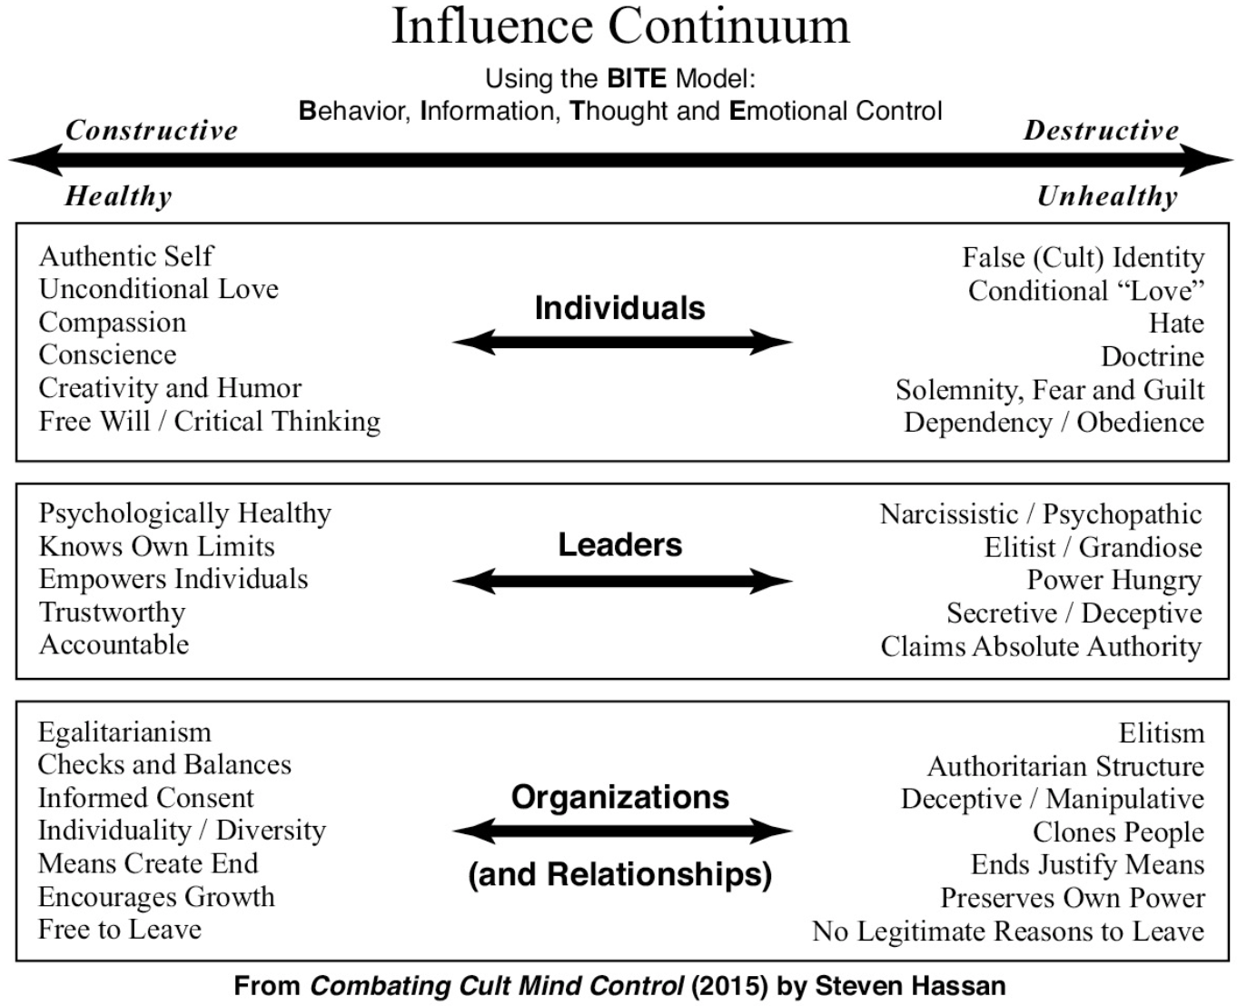

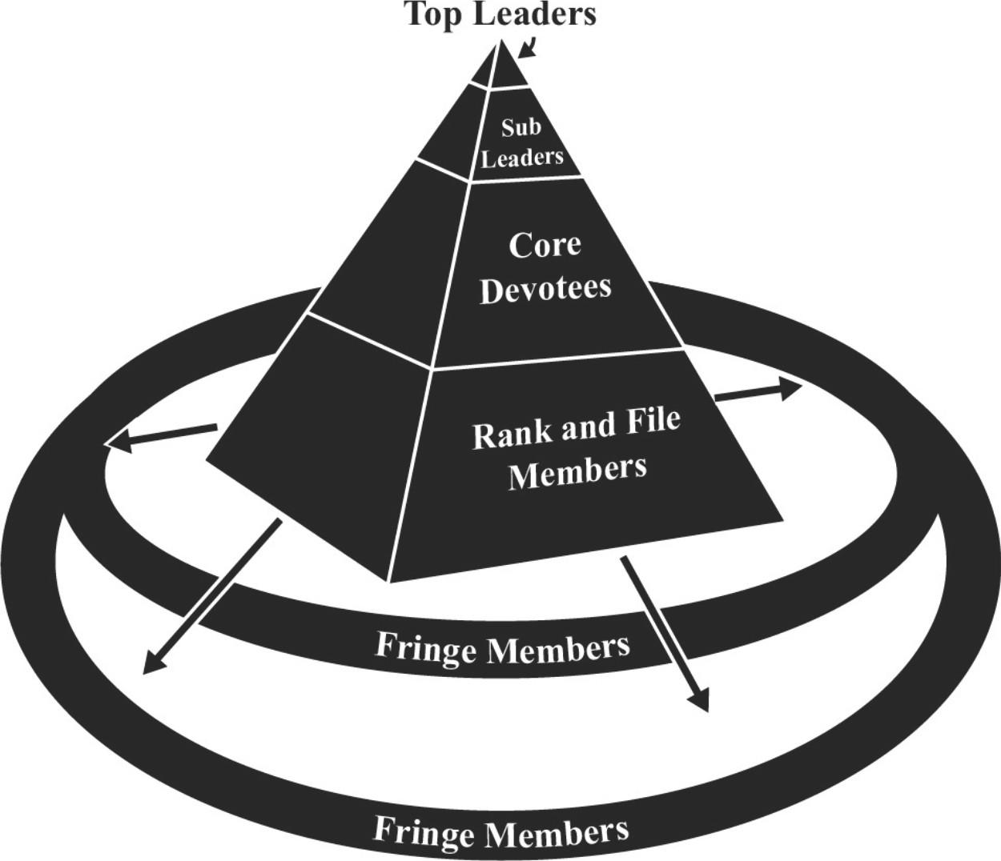
Destructive Cult Structure (Hassan, 2019)

Bite Model:

Behavior
Information
Thought
Emotion

BITE Model:

Behavior Control

  - Regulate an individual’s physical reality
  - Dictate where, how, and with whom the member lives and associates or isolates
  - Dictate when, how, and with whom the member has sex
  - Control types of clothing and hairstyles
  - Regulate diet—food and drink, hunger, and/or fasting
  - Manipulate and limit sleep
  - Financial exploitation, manipulation, or dependence
  - Restrict leisure, entertainment, vacation time
  - Major time spent with group indoctrination and rituals and/or self-indoctrination, including the internet
  - Require permission for major decisions
  - Report thoughts, feelings, and activities (of self and others) to superiors
  - Use rewards and punishments to modify behaviors, both positive and negative
  - Discourage individualism, encourage groupthink
  - Impose rigid rules and regulations
  - Encourage and engage in corporal punishment
  - Punish disobedience. Extreme examples done by pimps are beating, torture, burning, cutting, rape, or tattooing/branding
  - Threaten harm to family or friends (by cutting off family/friends)
  - Force individual to rape or be raped
  - Instill dependency and obedience

Information Control

- Deception
  - Deliberately withhold information
  - Distort information to make it more acceptable
  - Systematically lie to the cult member
- Minimize or discourage access to noncult sources of information, including:
  - Internet, TV, radio, books, articles, newspapers, magazines, other media
  - Critical information
  - Keep members busy so they don’t have time to think and investigate
  - Exert control through a cell phone with texting, calls, and internet tracking
- Compartmentalize information into Outsider versus Insider doctrines
- Ensure that information is not easily accessible
- Control information at different levels and missions within the group
- Allow only leadership to decide who needs to know what and when
- Encourage spying on other members
- Impose a buddy system to monitor and control member
- Report deviant thoughts, feelings, and actions to leadership
- Ensure that individual behavior is monitored by the group
- Extensive use of cult-generated information and propaganda, including:
  - Newsletters, magazines, journals, audiotapes, videotapes, YouTube, movies, and other media
  - Misquoting statements or using them out of context from noncult sources
- Unethical use of confession
- Use information about “sins” to disrupt and/or dissolve identity boundaries
- Withhold forgiveness or absolution
- Manipulate memory, possibly implanting false memories

Thought Control

- Require members to internalize the group’s doctrine (dogma) as truth
- Adopt the group’s “map of reality” as reality
- Instill black and white thinking
- Decide between good versus evil
- Organize people into us versus them (insiders versus outsiders)
- Change a person’s name and identity
- Use loaded language and clichés to constrict knowledge, stop critical thoughts, and reduce complexities into platitudinous buzzwords
- Encourage only “good and proper” thoughts
- Use hypnotic techniques to alter mental states, undermine critical thinking, and even to age-regress the member to childhood states
- Manipulate memories to create false ones
- Teach thought stopping techniques that shut down reality testing by stopping negative thoughts and allowing only positive thoughts. These techniques include:
  - Denial, rationalization, justification, wishful thinking
  - Chanting
  - Meditating
  - Praying
  - Speaking in tongues
  - Singing or humming
- Reject rational analysis, critical thinking, constructive criticism
- Forbid critical questions about leader, doctrine, or policy
- Label alternative belief systems as illegitimate, evil, or not useful
- Instill new “map of reality”

Emotional Control (In Good or Bad faith?)

- Manipulate and narrow the range of feelings—some emotions and/or needs are deemed as evil, wrong, or selfish
- Teach emotion stopping techniques to block feelings of hopelessness, anger, or doubt
- Make the person feel that problems are always their own fault, never the leader’s or the group’s fault
- Promote feelings of guilt or unworthiness, such as:
  - Identity guilt
  - You are not living up to your potential
  - Your family is deficient
  - Your past is suspect
  - Your affiliations are unwise
  - Your thoughts, feelings, actions are irrelevant or selfish
  - Social guilt
  - Historical guilt
- Instill fear, such as fear of:
  - Thinking independently
  - The outside world
  - Enemies
  - Losing one’s salvation
  - Leaving
- Orchestrate emotional highs and lows through love bombing and by offering praise one moment, and then declaring a person is a horrible sinner
- Ritualistic and sometimes public confession of sins
- Phobia indoctrination: inculcate irrational fears about leaving the group or questioning the leader’s authority
  - No happiness or fulfillment possible outside the group
  - Terrible consequences if you leave: hell, demon possession, incurable diseases, accidents, suicide, insanity, 10,000 reincarnations, etc.
  - Shun those who leave and inspire fear of being rejected by friends and family
  - Never a legitimate reason to leave; those who leave are weak, undisciplined, unspiritual, worldly, brainwashed by family or counselor, or seduced by money, sex, or rock and roll
- Threaten harm to ex-member and family (threats of cutting off friends/family)

From: “The Cult of Trump” (by Hassan, 2020)

- Create your own social reality by eliminating all sources of information other than that provided by the cult (in Trump’s words, fake news). Provide a picture of your world (a walled-in America) that members can use to interpret all events.
- Create an in-group of followers (Trump supporters) in contrast to an evil out-group (Democrats, Mexicans, Muslims, RINOs) to be hated and feared.
- Create an escalating spiral of commitment, beginning with simple requests (small donations, rally attendance).
- Establish your credibility and attractiveness through myths and stories that can be passed from member to member (that Trump made his own fortune and was chosen by God to lead the nation).
- Send members out to proselytize the unredeemed (Campaign!).
- Prevent members from thinking undesirable thoughts by continually distracting them (with outrageous tweets or by manufacturing your own fake news).
- Dangle a notion of a promised land before the faithful (Make America Great Again, but only for true believers).

Excerpt From: Steven Hassan. “The Cult of Trump.” iBooks.

Gaslighting

From: https://www.lifehack.org/articles/communication/how-to-win-arguments-dos-donts-and-sneaky-tactics.html
Do
- Stay calm. Even if you get passionate about your point you must stay cool and in command of your emotions. If you lose your temper – you lose.
- Use facts as evidence for your position. Facts are hard to refute so gather some pertinent data before the argument starts. Surveys, statistics, quotes from relevant people and results are useful arguments to deploy in support of your case.
- Ask questions. If you can ask the right questions you can stay in control of the discussion and make your opponent scramble for answers. You can ask questions that challenge his point, ‘What evidence do you have for that claim?’ You can ask hypothetical questions that extrapolate a trend and give your opponent a difficulty, ‘What would happen if every nation did that?’ Another useful type of question is one that calmly provokes your foe, ‘What is about this that makes you so angry?’
- Use logic. Show how one idea follows another. Build your case and use logic to undermine your opponent.
- Appeal to higher values. As well as logic you can use a little emotion by appealing to worthy motives that are hard to disagree with, ‘Shouldn’t we all be working to make the world better and safer for our children?’
- Listen carefully. Many people are so focused on what they are going to say that they ignore their opponent and assume his arguments. It is better to listen carefully. You will observe weaknesses and flaws in his position and sometimes you will hear something new and informative!
- Be prepared to concede a good point. Don’t argue every point for the sake of it. If your adversary makes a valid point then agree but outweigh it with a different argument. This makes you looked reasonable. ‘I agree with you that prison does not reform prisoners. That is generally true but prison still acts effectively as a deterrent and a punishment.’
- Study your opponent. Know their strengths, weaknesses, beliefs and values. You can appeal to their higher values. You can exploit their weaknesses by turning their arguments back on them.
- Look for a win-win. Be open-minded to a compromise position that accommodates your main points and some of your opponent’s. You cannot both win in a boxing match but you can both win in a negotiation.
Don’t
- Get personal. Direct attacks on your opponent’s lifestyle, integrity or honesty should be avoided. Attack the issue not the person. If the other party attacks you then you can take the high ground e.g.’ I am surprised at you making personal attacks like that. I think it would be better if we stuck to the main issue here rather than maligning people.’
- Get distracted. Your opponent may try to throw you off the scent by introducing new and extraneous themes. You must be firm. ‘That is an entirely different issue which I am happy to discuss later. For the moment let’s deal with the major issue at hand.’
- Water down your strong arguments with weak ones. If you have three strong points and two weaker ones then it is probably best to just focus on the strong. Make your points convincingly and ask for agreement. If you carry on and use the weaker arguments then your opponent can rebut them and make your overall case look weaker.

Some Sneaky Ways to Consider
- Use punchy one-liners. You can sometimes throw your opponent out of his stride by interjecting a confident, concise cliché. Here are some good ones:
  - That begs the question.
  - That is beside the point.
  - You’re being defensive.
  - Don’t compare apples and oranges.
  - What are your parameters?
- Ridicule and humiliate your opponent. This can be very effective in front of an audience but will never win over the opponent himself.
- Deliberately provoke your adversary. Find something that makes them angry and keep wheedling away on this point until they lose their temper and so the argument.
- Distract. Throw in diversions which deflect the other person from their main point.
- Exaggerate your opponent’s position. Take it way beyond its intended level and then show how ridiculous and unreasonable the exaggerated position is.
- Contradict confidently. Vigorously denounce each of your opponent’s arguments as fallacious but just select one or two that you can defeat to prove the point. Then assume that you have won.

https://cdn.lifehack.org/wp-content/uploads/2008/07/productive-arguement.png

How to have a productive argument at work:

07-11-21:
http://www.mnei.nl/schopenhauer/38-stratagems.htm
Arthur Schopenhauer (1788-1860), was a brilliant German philosopher. These 38 Stratagems are excerpts from "The Art of Controversy", first translated into English and published in 1896.
Schopenhauer's 38 ways to win an argument are:
- Carry your opponent's proposition beyond its natural limits; exaggerate it. The more general your opponent's statement becomes, the more objections you can find against it. The more restricted and narrow his or her propositions remain, the easier they are to defend by him or her.
- Use different meanings of your opponent's words to refute his or her argument.
- Ignore your opponent's proposition, which was intended to refer to a particular thing. Rather, understand it in some quite different sense, and then refute it. Attack something different than that which was asserted.
- Hide your conclusion from your opponent till the end. Mingle your premises here and there in your talk. Get your opponent to agree to them in no definite order. By this circuitious route you conceal your game until you have obtained all the admissions that are necessary to reach your goal.
- Use your opponent's beliefs against him. If the opponent refuses to accept your premises, use his own premises to your advantage.
- Another plan is to confuse the issue by changing your opponent's words or what he or she seeks to prove.
- State your proposition and show the truth of it by asking the opponent many questions. By asking many wide-reaching questions at once, you may hide what you want to get admitted. Then you quickly propound the argument resulting from the opponent's admissions.
- Make your opponent angry. An angry person is less capable of using judgement or perceiving where his or her advantage lies.
- Use your opponent's answers to your questions to reach different or even opposite conclusions.
- If your opponent answers all your questions negatively and refuses to grant any points, ask him or her to concede the opposite of your premises. This may confuse the opponent as to which point you actually seek them to concede.
- If the opponent grants you the truth of some of your premises, refrain from asking him or her to agree to your conclusion. Later, introduce your conclusion as a settled and admitted fact. Your opponent may come to believe that your conclusion was admitted.
- If the argument turns upon general ideas with no particular names, you must use language or a metaphor that is favorable in your proposition.
- To make your opponent accept a proposition, you must give him or her an opposite, counter-proposition as well. If the contrast is glaring, the opponent will accept your proposition to avoid being paradoxical.
- Try to bluff your opponent. If he or she has answered several of your questions without the answers turning out in favor of your conclusion, advance your conclusion triumphantly, even if it does not follow. If your opponent is shy or stupid, and you yourself possess a great deal of impudence and a good voice, the trick may easily succeed.
- If you wish to advance a proposition that is difficult to prove, put it aside for the moment. Instead, submit for your opponent's acceptance or rejection some true proposition, as though you wished to draw your proof from it. Should the opponent reject it because he or she suspects a trick, you can obtain your triumph by showing how absurd the opponent is to reject a true proposition. Should the opponent accept it, you now have reason on your own for the moment. You can either try to prove your original proposition or maintain that your original proposition is proved by what the opponent accepted. For this, an extreme degree of impudence is required.
- When your opponent puts forth a proposition, find it inconsistent with his or her other statements, beliefs, actions, or lack of action.
- If your opponent presses you with a counter proof, you will often be able to save yourself by advancing some subtle distinction. Try to find a second meaning or an ambiguous sense for your opponent's idea.
- If your opponent has taken up a line of argument that will end in your defeat, you must not allow him or her to carry it to its conclusion. Interrupt the dispute, break it off altogether, or lead the opponent to a different subject.
- Should your opponent expressly challenge you to produce any objection to some definite point in his or her argument, and you have nothing much to say, try to make the argument less specific.
- If your opponent has admitted to all or most of your premises, do not ask him or her directly to accept your conclusion. Rather draw the conclusion yourself as if it too had been admitted.
- When your opponent uses an argument that is superficial, refute it by setting forth its superficial character. But it is better to meet the opponent with a counter argument that is just as superficial, and so dispose of him or her. For it is with victory that your are concerned, and not with truth.
- If your opponent asks you to admit something from which the point in dispute will immediately follow, you must refuse to do so, declaring that it begs the question.
- Contradiction and contention irritate a person into exaggerating his or her statements. By contradicting your opponent you may drive him or her into extending the statement beyond its natural limit. When you then contradict the exaggerated form of it, you look as though you had refuted the original statement your opponent tries to extend your own statement further than you intended, redefine your statement's limits.
- This trick consists in stating a false syllogism. Your opponent makes a proposition and by false inference and distortion of his or her ideas you force from the proposition other propositions that are not intended and that appear absurd. It then appears the opponent's proposition gave rise to these inconsistencies, and so appears to be indirectly refuted.
- If your opponent is making a generalization, find an instance to the contrary. Only one valid contradiction is needed to overthrow the opponent's proposition.
- A brilliant move is to turn the tables and use your opponent's arguments against him or herself.
- Should your opponent surprise you by becoming particularly angry at an argument, you must urge it with all the more zeal. Not only will this make the opponent angry, it may be presumed that you put your finger on the weak side of his or her case, and that the opponent is more open to attack on this point than you expected.
- This trick is chiefly practicable in a dispute if there is an audience who is not an expert on the subject. You make an invalid objection to your opponent who seems to be defeated in the eyes of the audience. This strategy is particularly effective if your objection makes the opponent look ridiculous or if the audience laughs. If the opponent must make a long, complicated explanation to correct you, the audience will not be disposed to listen.
- If you find that you are being beaten, you can create a diversion that is, you can suddenly begin to talk of something else, as though it had bearing on the matter in dispose. This may be done without presumption if the diversion has some general bearing on the matter.
- Make an appeal to authority rather than reason. If your opponent respects an authority or an expert, quote that authority to further your case. If needed, quote what the authority said in some other sense or circumstance. Authorities that your opponent fails to understand are those which he or she generally admires the most. You may also, should it be necessary, not only twist your authorities, but actually falsify them, or quote something that you have invented entirely yourself.
- If you know that you have no reply to an argument that your opponent advances, you may, by a fine stroke of irony, declare yourself to be an incompetent judge.
- A quick way of getting rid of an opponent's assertion, or throwing suspicion on it, is by putting it into some odious category.
- You admit your opponent's premises but deny the conclusion.
- When you state a question or an argument, and your opponent gives you no direct answer, or evades it with a counter question, or tries to change the subject, it is a sure sign you have touched a weak spot, sometimes without knowing it. You have as it were, reduced the opponent to silence. You must, therefore, urge the point all the more, and not let your opponent evade it, even when you do not know where the weakness that you have hit upon really lies.
- This trick makes all unnecessary if it works. Instead of working on an opponent's intellect, work on his or her motive. If you succeed in making your opponent's opinion, should it prove true, seem distinctly to his or her own interest, the opponenent will drop it like a hot potato.
- You may also puzzle and bewilder your opponent by mere bombast. If the opponent is weak or does not wish to appear as ife he or she has no idea what you are talking about, you can easily impose upon him or her some argument that sounds very deep or learned, or that sounds indisputable.
- Should your opponent be in the right but, luckily for you, choose a faulty proof, you can easily refute it and then claim that you have refuted the whole position. This is the way which bad advocates lose a good case. If no accurate proof occurs to the opponent or the bystanders, you have won the day.
- A last trick is to become personal, insulting and rude as soon as you perceive that your opponent has the upper hand. In becoming personal you leave the subject altogether, and turn your attack on the person by remarks of an offensive and spiteful character. This is a very popular trick, because everyone is able to carry it into effect.
-----------------------------------
07-15-2021: https://uh.edu/~englin/rephandout.html

The following is taken from Language: A Key Mechanism of Control, a pamphlet which was sent to Republican candidates running in the 1990 elections. The pamphlet was developed by Gopac, a conservative group headed by the then House Republican Whip Newt Gingrich. This excerpt appeared in the November 1990 issue of Harpers Magazine. From the rhetorical analyst's position it constitutes a pile of examples of loaded diction (see RT&C). You might want to have some fun with this by thinking about whether there would be differences between this 90 and a possible 96 list. Consider, in this regard what the implications are for the "absoluteness" of the terms "negative" and "positive."
As you know, one of the key points in the Gopac [instructional tapes] is that "language matters." As we mail tapes to candidates, and use them in training sessions across the country, we hear a plaintive plea: "I wish I could speak like Newt." That takes years of practice. But we believe that you can have a significant impact on your campaign if we help a little. That is why we have created this list of words and phrases. This list is prepared so that you might have a directory of words to use in writing literature and letters, in preparing speeches, and in producing material for the electronic media. The words and phrases are powerful. Read them. Memorize as many as possible. And remember that, like any tool, these words will not help if they are not used.

Optimistic Positive Governing Words
Use the list below to help define your campaign and your vision of public service. These words can help give extra power to your message.
common sense | freedom | peace | reform
courage | hard work | pioneer | rights
crusade | help | precious | strength
dream | liberty | pride | truth
duty | light | principle(d) | vision
empower(ment) | moral | pristine | workfare
fair | movement | pro-environment
family | passionate | prosperity

Contrasting Words
Often we search hard for words to define our opponents. Sometimes we are hesitant to use contrast. These are powerful words that can create a clear and easily understood contrast. Apply these to the opponent, his record, proposals and party.
anti-child | deeper | liberal | shallow
anti-flag | disgrace | lie | shame
betray | devour | machine | sick
bizarre | destroy | obsolete | status quo
cheat | excuses | pathetic | steal
collapse | failure | radical | taxes
corruption | greed | red tape | they/them
crisis | hypocrisy | self-serving | traitors
decay | incompetent | sensationalists | welfare

From:

Norman, Andy, Steven Pinker, and Charles Constant. 2021. Mental immunity: infectious ideas, mind-parasites, and the search for a better way to think. HarperCollins, New York. (p.70)

Six (Mental) Immune Disruptive Ideas:

1) Beliefs are private, and no one else’s concern. (What I believe is none of your business!)(asw)
2) We have a right to believe what we like. (Right to believe ruse)(It’s a free country!)(asw)
3) Values are subjective—relative, that is, to a fundamentally arbitrary set of preferences. (who appointed you the thought-police?)
4) We have no standing to criticize other people’s value judgments.
5) Basic value commitments are not subject to rational assessment.
6) Questioning a person’s core commitments is fundamentally intolerant, mean-spirited, offensive, or unkind. (Don’t you tell me what to do!)(asw)

From Mental Immunity: Page 80:
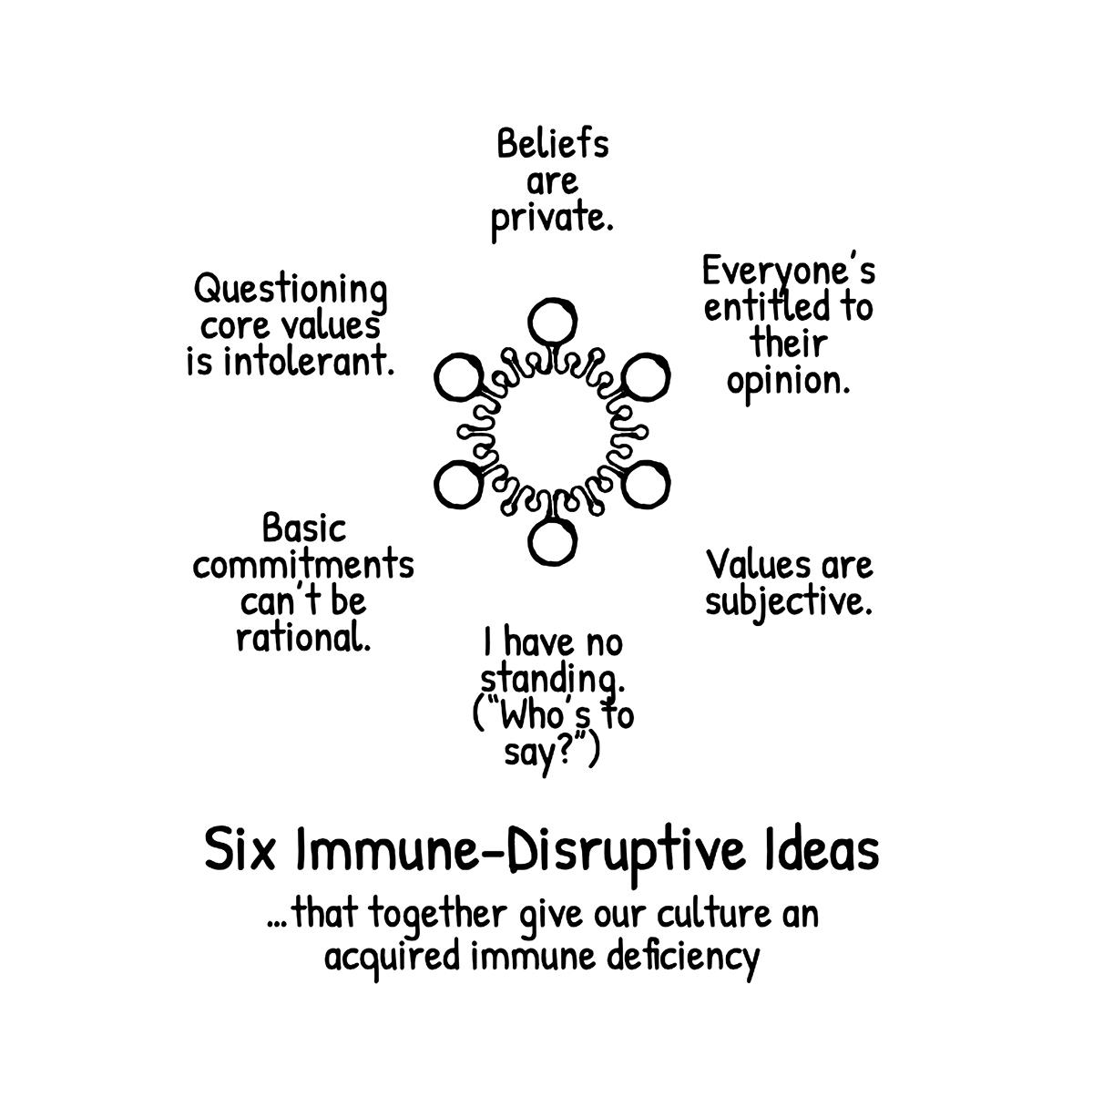
From Mental Immunity: Page 85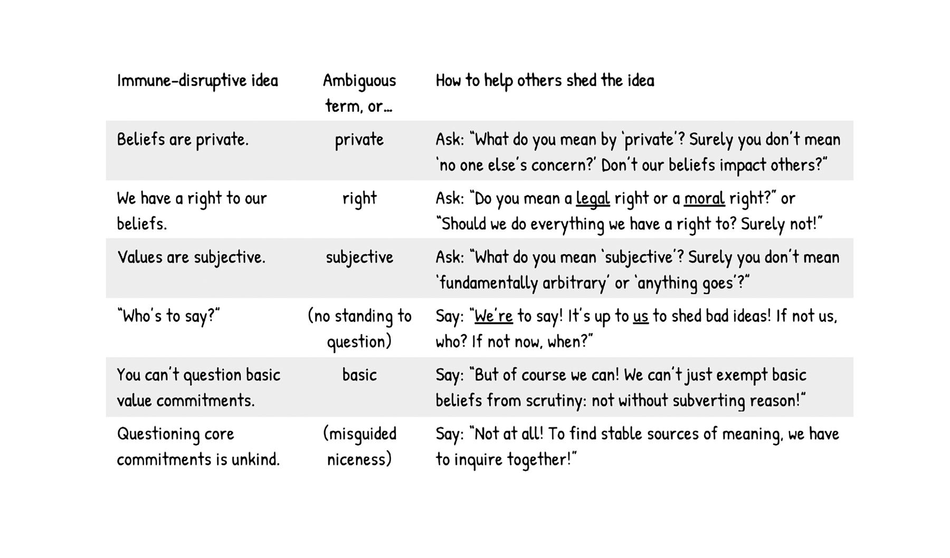

From: Levin Mark R. 2023. The Democrat Party Hates America First Threshold editions hardcover ed. New York: Threshold Editions. P.25-26

CHAPTER ONE
THE DEMOCRAT PARTY & AUTHORITARIANISM
P.25:
…Saul Alinsky, a Marxist and Gramsci fan, wrote Rules for Radicals: A Pragmatic Primer for Realistic Radicals, based essentially on Gramsci’s approach. Importantly, Alinsky was a key mentor to Hillary Clinton, who in 1969 wrote her ninety-two-page senior thesis on Alinsky at Wellesley College; and his writings were extremely influential with a young community activist, Barack Obama…
P.26
Alinsky’s rules for balkanizing and dividing society, undermining faith in America’s institutions, and laying the groundwork for revolution have had a gravely deleterious eect on the nation’s civility, rule of law, and tranquility. Here are his rules:
1. Power is not only what you have but what the enemy thinks you have.
2. Never go outside the expertise of your people.
3. Whenever possible go outside the expertise of the enemy.
4. Make the enemy live up to its own book of rules.
5. Ridicule is man’s most potent weapon. There is no defense. It is almost impossible to counterattack ridicule. Also, it infuriates the opposition, who then react to your advantage.
6. A good tactic is one your people enjoy.
7. A tactic that drags on too long becomes a drag.
8. Keep the pressure on.
9. The threat is usually more terrifying than the thing itself.
10. The major premise for tactics is the development of operations that will maintain a constant pressure upon the opposition.
11. If you push a negative hard and deep enough it will break through into its counter side; this is based on the principle that every positive has its negative.
12. The price of a successful attack is a constructive alternative.
13. Pick the target, freeze it, personalize it, and polarize it.⁴⁴
Saul D. Alinsky, Rules for Radicals: A Practical Primer for Realistic Radicals (New York, Vintage Books, 1971), 126-130.
Next: The 10 Rules of Hate by Matt Taibbi (2019)
From:
Taibbi Matt. 2019. Hate Inc. : Why Today's Media Makes Us Despise One Another. New York: OR Books.
Chapter 2: The Ten Rules of Hate
1. THERE ARE ONLY TWO IDEAS
2. THE TWO IDEAS ARE IN PERMANENT CONFLICT
3. HATE PEOPLE, NOT INSTITUTIONS
4. EVERYTHING IS SOMEONE ELSE’S FAULT
5. NOTHING IS EVERYONE’S FAULT
6. ROOT, DON’T THINK
7. NO SWITCHING TEAMS
8. THE OTHER SIDE IS LITERALLY HITLER
9. IN THE FIGHT AGAINST HITLER, EVERYTHING IS PERMITTED
10. FEEL SUPERIOR
(asw) 11. INVENT DRAMA (from later in Taibbi book)(after WWE)
Differentiating Bias and Lies
Next: From Government Teacher, Minnesotan Sharon McMahon: “I need to spend a lot of time educating on the difference between bias and lie.” “Look at information across the (political spectrum)(but) Always fall back to primary sources (finding actual documents).”
ASW: A lie is an assertion, argument, premise, conclusion, that is not based in “clear and compelling evidence” or objective fact.
https://www.youtube.com/watch?v=sZOh-As5mOQ
“In the end, you don’t get Bonus Points for spending your life feeling outraged.” 1m 13s elapsed: (https://www.youtube.com/watch?v=auLGVXa6cX4)
14 Types of Bias from https://www.masterclass.com/articles/how-to-identify-bias

14 Types of Bias
When it comes to human behavior, there are many common types of bias we have that can influence the way we think and act in our everyday lives.
- 1. Confirmation bias. This type of bias refers to the tendency to seek out information that supports something you already believe, and is a particularly pernicious subset of cognitive bias—you remember the hits and forget the misses, which is a flaw in human reasoning. People will cue into things that matter to them, and dismiss the things that don’t, which can lead to the “ostrich effect” (named so because ostriches bury their heads in the sand), where a subject seeks to avoid information that may disprove their original point.
- 2. The Dunning-Kruger Effect. This particular bias refers to how people perceive a concept or event to be simplistic just because their knowledge about it may be simple or lacking—the less you know about something, the less complicated it may appear. However, this form of bias limits curiosity—people don’t feel the need to further explore a concept, because it seems simplistic to them. This bias can also lead people to think they are smarter than they actually are because they have reduced a complex idea to a simplistic understanding.
- 3. Cultural bias. Cultural bias, also known as implicit bias, involves those who perceive other cultures as being abnormal, outlying, or exotic, simply based on a comparison to their own culture. Also known as implicit social cognition, this bias attributes the traits and behaviors of an individual to a larger group of people. Implicit bias creates attitudes or stereotypes that can affect or influence our decisions in an unconscious way. This unconscious bias affects many people because they are unaware of the origins of their baseline of thinking.
- 4. In-group bias. This type of bias refers to how people are more likely to support or believe someone within their own social group than an outsider. This bias tends to remove objectivity from any sort of selection or hiring process, as individuals tend to favor those who they personally know and want to help.
- 5. Decline bias. The decline bias refers to the tendency to compare the past to the present, leading to the decision that things are worse, or becoming worse in comparison to the past, simply because change is occurring.
- 6. Optimism or pessimism bias. This bias refers to how individuals are more likely to estimate a positive outcome if they are in a good mood, and a negative outcome if they are in a bad mood.
- 7. Self-serving bias. A self-serving bias is an assumption that good things happen to us when we’ve done all the right things, but bad things happen to us because of circumstances outside our control or things other people purport. This bias results in a tendency to blame outside circumstances for bad situations rather than taking personal responsibility.
- 8. Information bias. Information bias is a type of cognitive bias that refers to the idea that amassing more information will aid in better decision-making, even if that extra information is irrelevant to the actual subject at hand.
- 9. Selection bias. This bias refers to the way individuals notice things more when something has happened to make us notice that particular thing more—like when you buy a car and suddenly notice more models of that car on the road. The car has simply become part of the individual’s observations, so they tend to observe it more elsewhere (also known as observational selection bias).
- 10. Availability bias. Also known as the availability heuristic, this bias refers to the tendency to use the information we can quickly recall when evaluating a topic or idea—even if this information is not the best representation of the topic or idea. Using this mental shortcut, we deem the information we can most easily recall as valid and ignore alternative solutions or opinions.
- 11. Fundamental attribution error. This bias refers to an individual’s tendency to attribute someone’s particular behaviors to existing, unfounded stereotypes, while attributing their own similar behavior to external factors. For instance, when someone on your team is late to an important meeting, you may assume that they are lazy or lacking motivation without considering internal and external factors like an illness or traffic accident that led to the tardiness. However, when you are running late because of a flat tire, you expect others to attribute the error to the external factor (flat tire) rather than your personal behavior.
- 12. Hindsight bias. Hindsight bias, also known as the knew-it-all-along effect, is when people perceive events to be more predictable after they happen. With this bias, people overestimate their ability to predict an outcome beforehand, even though the information they had at the time would not have led them to the correct outcome. This type of bias happens often in sports and world affairs. Hindsight bias can lead to overconfidence in one’s ability to predict future outcomes.
- 13. Anchoring bias. The anchoring bias, or focalism, pertains to those who rely too heavily on the first piece of information they receive—an “anchoring” fact— and base all subsequent judgments or opinions on this fact. For instance, if you tell someone a picture frame costs $20 and they go to a store that sells it for $15, their anchoring bias will lead them to perceive the $15 frame as a bargain, even though it may be on sale at a different store for $10. With anchoring bias, the initial price of the frame will influence a person’s perception of its value.
- 14. Observer bias. The observer bias occurs when someone’s evaluation of another person is influenced by their own inherent cognitive biases. Observers, like researchers or scientists, may assess the outcome of an experiment differently depending on their existing evaluations of the current subject. Subsequently, the subject that is under observation may alter their behavior if they know they are being observed. Double-blind studies are often implemented to overcome observer bias.

A.S. Wright:
Inoculation:
Exposure to small doses of pathogenic material in context, so as to promote development of more rapid criticcal identification of and heightened personal choice, as whether to accept and/or participate in questionable arguments, premises, conclusions, evidence, biases, beliefs, values, or behaviors, most likely repeatedly offered in an environment of heightened emotion and short time frame, with a threat of exclusion from a presented perceptual group or benefit, if quick, uncritical action is not taken. Intention: to continue to develop critical skill to choose to act in the good-faith, best interest, of self, relationship, family, community.
How is a mongoose immune from cobra venom? Cobra venom acts to block the acetylcholine receptors in motor neurons so as to paralyze the recipient of venom. Mongoose acetylcholine receptors have mutated so the cobra venom simply bounces off the mutated receptors in the mongoose. Not pleasant to be bitten, but at least not paralyzed.

Indoctrination (negative)
“Instruction of prisoners of war…” equivalent to Brainwashing: (From OED: ) “The systematic and often forcible elimination from a person's mind of all established ideas, esp. political ones, so that another set of ideas may take their place; this process regarded as the kind of coercive conversion practised by certain totalitarian states on political dissidents. Also attributive and in weakened sense: the action of pressurizing or persuading a person into a belief considered undesirable.”
Intimidation
(From OED) The action of intimidating or making afraid; the fact or condition of being intimidated; now, esp. the use of threats or violence to force to or restrain from some action, or to interfere with the free exercise of political or social rights.

